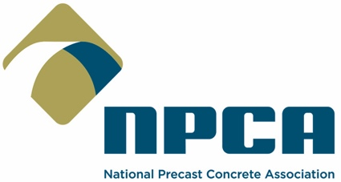

FOR IMMEDIATE RELEASE CONTACT: Heather Bremer, Communications
March 5, 2024 Phone: 317-582-2315, E-mail: hbremer@precast.org

Production & Quality School Level I
now available in Spanish

The National Precast Concrete Association (NPCA) has released the introductory course of its Production & Quality School (PQS) program in Spanish.

PQS I covers the basic body of knowledge that all employees need to be successful at a precast concrete plant. The course, offered online, is a comprehensive program devoted to addressing the key fundamentals of producing quality precast concrete.

Developed by veteran industry experts, PQS I details each critical step of the concrete production process from start to finish, including batching and mixing, reinforcement, production practices and quality control. It also is the first step industry employees take in achieving the Master Precaster® designation, earned through completing a precast-specific training curriculum on production, safety, technical, quality control and leadership.

The Spanish-language version of PQS I was meticulously translated to provide the same industry-leading education as the English-language version in both the lessons and testing.

“In response to industry demand, NPCA is excited to share the launch of PQS I in Spanish,” NPCA President and CEO Nick Rhoad said. “This will allow our members to make precast-specific training more accessible to their Spanish-speaking employees and strengthen the workforce in plants at the heart of building and maintaining our nation’s infrastructure.”

Learn more about NPCA’s PQS and Master Precaster programs at Precast.org/master-precaster.

***

ABOUT NPCA: Based in Carmel, Ind., NPCA has represented manufacturers of industrial plant-produced precast concrete products and the suppliers of products and services for the industry since 1965, providing members with the programs and information required to operate a successful precast plant. NPCA operates the industry’s largest and most comprehensive plant certification program, which is accredited by the ANSI National Accreditation Board (ANAB).

ABOUT PRECAST CONCRETE: Precast is the ideal construction material for projects that endure for generations. It is prepared, cast and cured in a controlled factory environment. Precast concrete products are the backbone of our nation’s infrastructure, used in the construction and building sectors in housing, commercial, Industrial, transportation and water and waste management.

