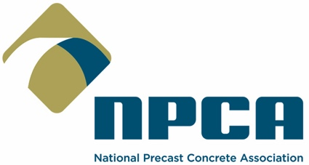

FOR IMMEDIATE RELEASE CONTACT: Communications Dept.
Dec. 6, 2023 Email: marcomm@precast.org / 800-366-7731

NPCA Master Precaster® Program To Be Available in Canada Through CPCI

The National Precast Concrete Association (NPCA) has licensed its Master Precaster program to the Canadian Precast/Prestressed Concrete Institute (CPCI) to enhance educational opportunities and workforce skills within the industry.

Individuals obtain Master Precaster status by completing six precast-specific courses that focus on general industry knowledge, production, safety, technical, quality control and leadership. Since its introduction in 2012, more than 400 individuals have completed the program and earned the title Master Precaster from NPCA.

Beginning in 2024, CPCI will offer Master Precaster courses through a combination of in-person and web-based events. The courses can be taken in any order, but all six must be completed to acquire the Master Precaster designation.

“The Master Precaster program is a well-established and highly regarded precast-specific worker training program built on the needs of our members,” NPCA President and CEO Nick Rhoad said. “We look forward to working alongside CPCI to continue skilling up the workforce, providing opportunities for production personnel so that we can help ensure the manufacturing of high-quality precast concrete products.”

CPCI President Val Sylaj said, “We are proud to partner with NPCA on this great education initiative. Providing a comprehensive training program such as the NPCA Master Precaster will go a long way toward educating our industry and further reinforcing the excellent relationship between our two organizations.”

Master Precasters trained by CPCI will receive the same recognition as those who complete the education through NPCA, including a certificate, a gold hard hat and inclusion in the annual graduation ceremony that takes place at The Precast Show®.

The NPCA Master Precaster training program includes:
- Production and Quality School (PQS) Level I. A baseline overview covering the body of knowledge that all precast concrete facility employees should know.
- PQS II-Safety. A comprehensive examination of safety issues associated with the precast concrete production process.
- PQS II-Production. An expansion of PQS I topics that includes more complex manufacturing techniques, lean manufacturing, repair procedures, reinforcement, lifting and handling.
- PQS II-Technical. An analysis of basic mechanics, design theory, proper lifting, understanding blueprints and industry standards.
- PQS II-Quality Assurance/Quality Control. A topical look at the standards required within the NPCA Quality Control Manual and NPCA Plant Certification.
- PQS III-Leadership. An exploration of leadership principles to strengthen management skills and cross-cultural workforces.

Learn more about NPCA’s Master Precaster program at Precast.org/master-precaster

***

ABOUT NPCA: Based in Carmel, Ind., NPCA has represented manufacturers of industrial plant-produced precast concrete products and the suppliers of products and services for the industry since 1965, providing members with the programs and information required to operate a successful precast plant. NPCA operates the industry’s largest and most comprehensive plant certification program, which is accredited by the ANSI National Accreditation Board (ANAB).

ABOUT CPCI: CPCI represents the precast concrete industry in Canada. Established in 1961 in Ottawa, Canada, its mission has been to be the body of knowledge for precast and prestressed concrete and to educate and raise awareness with key decision-makers on the outstanding attributes of precast concrete products and systems. CPCI’s main focus is to advance the use of precast and prestressed concrete products and assemblies through investigations, research and development of design guidelines and industry best practices.

